Project Design Phase
Solution Architecture

Date | 27 june 2025
Team ID | LTVIP2025TMID59173
Project Name | HealthAI: Intelligent Healthcare Assistant Using IBM Granite
Maximum Marks | 4 Marks
Solution Architecture: Health AI
Definition & Purpose:
Solution architecture in Health AI bridges the gap between healthcare needs and AI-driven technology. It defines the structure and components needed to develop an AI-based health assistant that can provide disease prediction, vitals monitoring, medical chat, and more.
The goals of the solution architecture in this project are to:
- Identify the best technologies to solve the problem of delayed and inaccessible healthcare support.
- Clearly describe the software structure, components, and data flow for all stakeholders.
- Break the system into phases like Registration → Prediction → Monitoring → Reporting.
- Provide technical specifications to guide development and ensure scalability, performance, and security.
- Example - Solution Architecture Diagram:

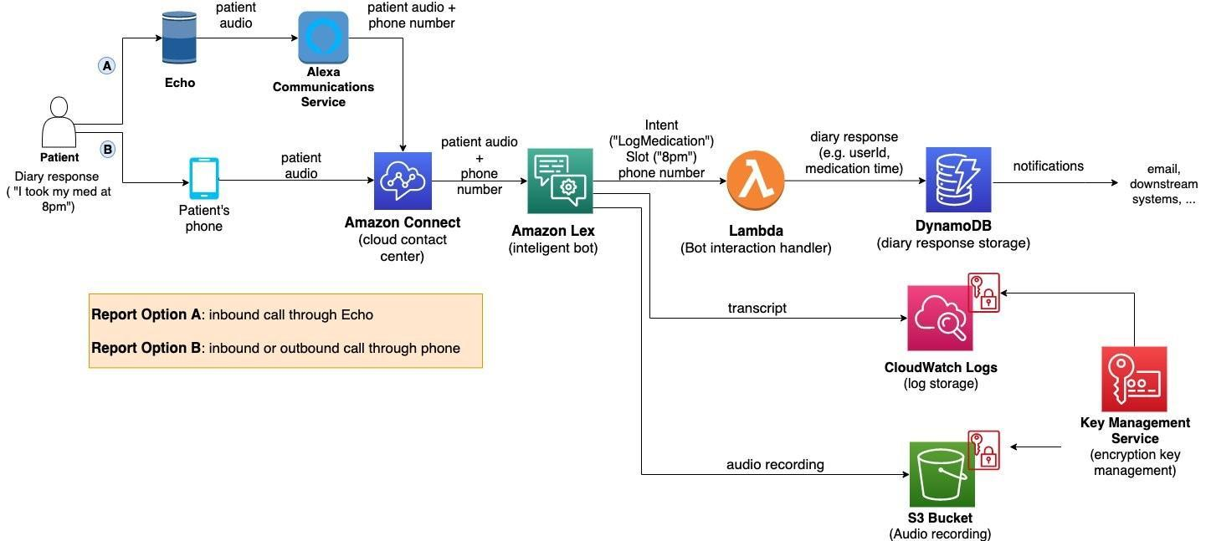
Figure 1: Architecture and data flow of the voice patient diary sample application
- Reference: https://aws.amazon.com/blogs/industries/voice-applications-in-clinical-research-powered-by-ai-on-aws-part-1-architecture-and-design-considerations/

